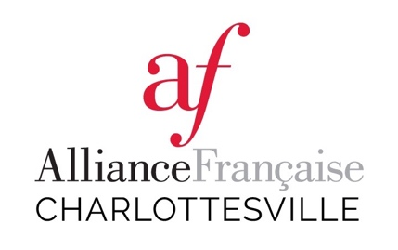
Bring out the Renoir in your child!

The Hollymead PTO and the Alliance Française are sponsoring a four-week French art class! Each week will focus on a different French artist. Students will learn French vocabulary associated with each artist’s work, the history and technique of their work, and will create a fun art project each week to represent that artist. No prior knowledge of French is necessary to enroll in this class.

Grades 1-2 will be taught by Stephanie Hall. Grades 3-5 will be taught by Michelle Katstra. Both teachers are experienced instructors with the Alliance Française and have been teaching after-school French at Hollymead over the past years.

The session cost is $60, with supplies included. Both classes will meet on Mondays, from 2:40-3:40. Class dates are: 4/30, 5/7, 5/14, and 5/21. Please fill out the registration form and submit payment to reserve your spot by Wednesday, April 25th. You may pay cash or write a check to the Hollymead PTO for $60. Please write your child’s name on the memo line.

Student’s Name: ____________________________________________

Grade Level: ____________ Homeroom Teacher: __________________

Parents’ Cell #s:_____________________________________________________
Parents’ Emails: _____________________________________________________

Will your child attend EDEP after our class? (circle one) YES NO

